S E M I N A R

Room 223B ZEC

Thursday, November 11, 2010 3:55 - 5:10 P.M.

Introduction to Medical Imaging

by
Eduardo Bartolome
Texas Instruments, In.c
Dallas, Texas

Abstract: New technologies in medical imaging are revolutionizing medical diagnostics and treatment. Radiographies with no film, CT scanners able to image a beating heart and ultrasound machines that can produce 3D images with systems of the size of a laptop are just some examples. This presentation will give an overview of these fascinating systems, from a technical perspective, with a description of the fundamental physics and the engineering behind, but it will also cover their medical applications, with their strengths and weaknesses, to finish with a look at the bigger picture, the current research and the market forces that may shape the future trends of this segment.

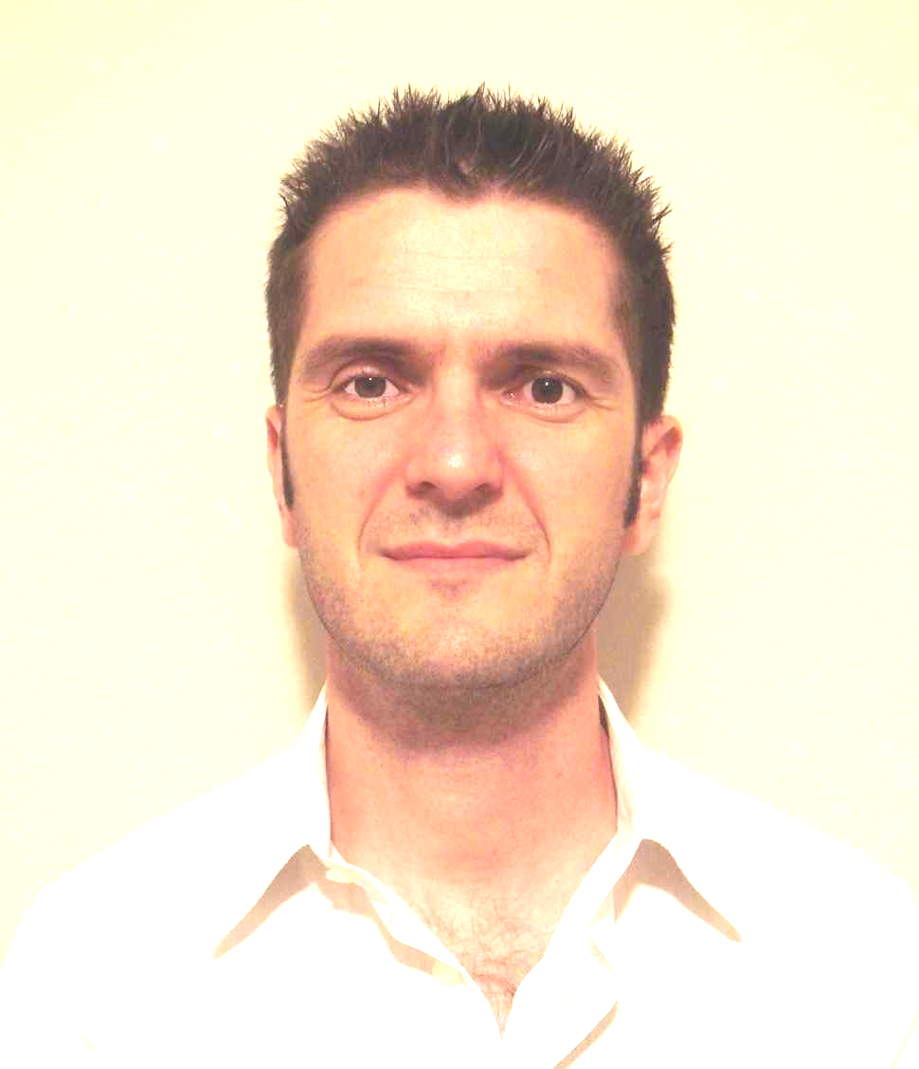
Mr. Eduardo Bartolome is a systems engineer in the high performance analog medical group, in Texas Instruments, where he joined more than 10 years ago. In this role Mr. Bartolome is responsible for the definition of integrated circuits that are at the core of today’s state of the art medical devices. He obtained an M.S. in Electrical Engineering from the Politechnic University of Catalonia, Spain and previous to his current role, he worked for 3 years in the IFAE, a high energy physics research institute in Spain where, among others, he developed ultra low dose detectors for digital radiography.

